Water. 4 Ways To Work It This Summer.

The iconic glass of water can sure get shafted this time a year in favor of its more colorful competitors. Fortunately, to get noticed, water’s taken it up a notch. As we head into summer, here’s how to make water hotter, yet cooler, for you and your family.

Tap Back In
As a reminder to simply turn on the tap to quench that thirst, I present to you the year’s best tap waters, as per the 25th Annual Berkeley Springs International Water Testing competition.

Best Municipal Water 2015
1st – Hamilton, OH
2nd – Emporia, KS
3rd – Clearbrook, Abbotsford BC, Canada
4th – (three way tie) Montpelier; OH, Dickinson, ND; Eldorado, CO
5th – Independence, MO

Howard County continually boasts high quality water, too. In fact, if you’re interested in the particulars, check out the most recent report.
I love the economy of tap water, and it doesn’t log-jam the pantry and recycling bin like bottles of stuff do.
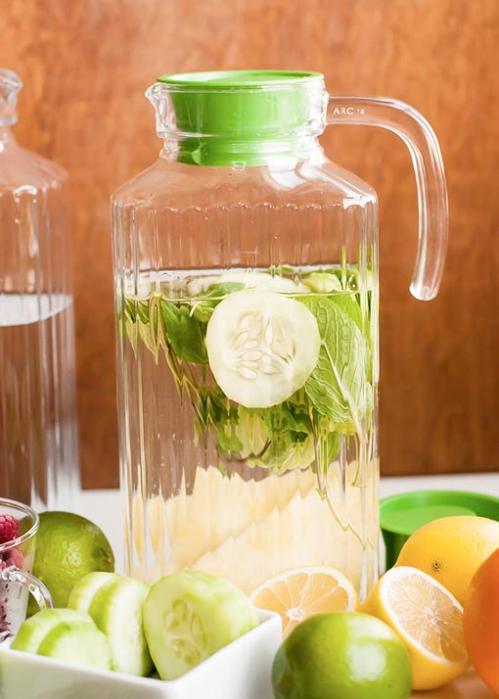
Create

Make water your summer soup. Get fancy (or kooky) and mix your favorite flavors. Let the kids in on the act. Pineapple cucumber mint is a favorite from hellonatural.co.

Muddle
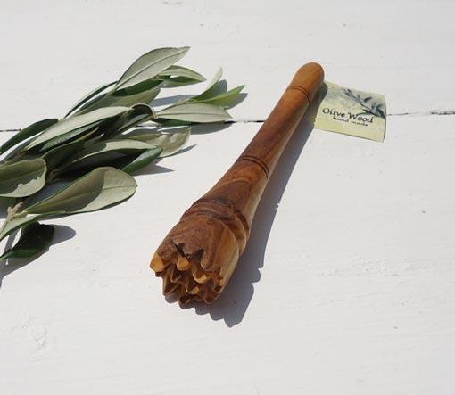
This is a muddler. It makes preparing infused waters more fun. I found this one on etsy.com, but you can create a makeshift muddler at home using the back of a wooden spoon.

Swig in Style
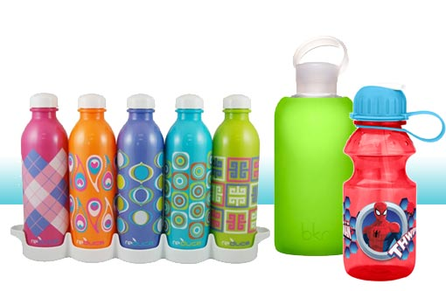
I learned this from a group of 14-year-old girls: water is cool because water bottles are cooler than soda and juice containers. They’ve got a good point. And with so many hip reusable bottles on the market, your water carrier can carry a style statement, too.

